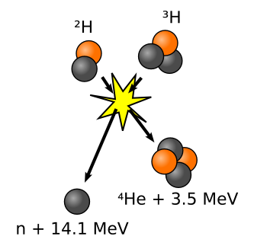
Nuclear fusion

- Consider the reaction represented by the equation:

$${}_{ 1}^{3}H + {}_{1}^{2}{H → {}_{2}^{4}{He + n + energy}}$$

a) Use the relative atomic mass data below to find the energy released when a tritium nucleus fuses with a deuterium nucleus.

³H = 3.016049 u ²H = 2.014102 u ⁴He = 4.002604 u n = 1.008665 u

- How much energy would become available from the fusion of about 2 grams of deuterium with 3 grams of tritium?

- A thermonuclear reaction is one which is caused by the energetic collisions of nuclei in a gas at very high temperatures. What temperatures would give the particles a mean translational energy of about 0.2 fJ, and thus enable the reaction to proceed?

3. In the Sun, fusion may take place between deuterium and tritium nuclei (see the equation in Q1). The total final mass of the particles is 5.0113 u. The energy released is 2.8 x 10⁻¹² J.

a) Find the mass equivalent, in kg, of the energy released.
b) Find the mass equivalent, in u, of the energy released.
c) Use the answer to b) to estimate the total mass of the nuclei, in u, before fusion.

4. Two almost stationary deuterium nuclei (²H) can fuse to form a tritium nucleus (³H) and a proton. This releases energy of 6.4 x 10⁻¹³ J.

- In what form is the energy released?
- Write an equation for this reaction.
- Calculate the ratio of the speed of the proton to that of the tritium nucleus.
- Calculate the ratio of the kinetic energy of the proton to that of the tritium nucleus.

5. The solar constant (the mean intensity of solar radiation arriving at the Earth) is 1.4 kW m⁻². If the mean distance of the Earth from the Sun is 1.5 x 10¹¹ m, what is

- the power of the Sun
- the rate of loss of mass of the Sun?

6. Calculate the energy in MeV released in the fusion reaction:

²H + ²H ³H + ¹H + energy

Use data from Q1 (¹H = 1.007825 u; 1u = 1.66 x 10⁻²⁷ kg)

Answers: Q1. a) 2.8 pJ b) 1.7 TJ Q2. 10⁷ K Q3. a) 3.1 x 10⁻²⁹ kg b) 0.0187 u c) 5.0300 u Q4. c) 3:1 d) 3:1 Q5. a) 4.0 x 10²⁶ W b) 4.4 x 10⁹ kg s⁻¹ Q6. 4.03 MeV

Q sources: Q1 [=63-45] & Q2 [=63-46] from pp 193 & 194, Questions and problems in pre-university physics (Whelan & Hodgson); Q3 [=3] & Q4 [=9], p 186, Advanced level study guides: physics (Arnold & Bloor); Q5 [=14.51], p157 Practice in physics (Akrill et al); Q6 [=Q3, Ex.29.1] p237, Calculations in A-level physics (Rounce & Lowe).

